

DVTK Design Specification
DVTK Script Support Assembly

1.0
2005-06-29

Table of Contents
1 Introduction 3
1.1 Purpose 3
1.2 Scope 3
1.3 Audience 3
1.4 Abbreviations and acronyms 3
1.5 References 3
1.6 History 3
2 Description of DVTKScriptSupport classes 4
2.1 DvtkScriptHost Class 4
2.1.1 Properties of DvtkScriptHost Class 4
2.1.2 Methods of DvtkScriptHost class 4
2.2 VsaScriptHost Class 4
2.2.1 Properties of VsaScriptHost Class 5
2.2.2 Methods of VsaScriptHost class 5
2.2.3 Definition of Interface implemented by VsaScriptHost class 6
2.3 VsaSite class 6
2.4 CompilerErrorEventArgs class 7
3 Generic Visual Basic Script Classes 9
3.1 TestCaseBase class 9
3.2 TestCase class 10
3.3 Button Handler class 11
3.4 DulDimseHandler class 11
3.5 MessageHandling class 11
3.6 ExpectedDicomMessage class 12
3.7 ExpectedDicomMessageCollection class 12
3.8 SessionThread class 13
3.9 SessionThreadDulDimseHandler class 14
3.10 SessionThreadSingleScript class 14
3.11 SopClasses class 15
3.12 TextOutputBase class 15
3.13 TextOutputMainAndCurrentSession class 16
3.14 TextOutputMainSession class 16
3.15 UserInteraction class 17
3.16 Utils class 17

Introduction

Purpose
This document describes the global and detail design of the DVTK Script Support component. This is a living document and changes in the design should be laid down in this document.

Scope
This document describes design of DVTK Script Support component and generic VB script classes. These VB script classes will be used by user to simulate complicated DICOM scenarios.

Audience
This document is intended for all the implementers in the DVT project. The reader is assumed to have basic DICOM knowledge.

Abbreviations and acronyms
Abbreviation / acronym | Description
DVT | DICOM Validation Tool.
Session File | File containing the test session parameters.
User | Person who is implementing the Definition library.

References
Reference | Title | Author/Publisher | Document number
SCRIPT | DICOMScript Language Specification | R. Busbridge | XZS 980-000118.00
DESIGNSPEC |  | R. Busbridge  M. van Minderhout | XZS 980-000183.01
PATTERNS | Design Patterns | E. Gamma et al. | ISBN 0201633612

History
Version | Date | Author | Description
0.1 | 27 June 2005 | Piyush Bhageriya  Manisha Singla | Initial version
1.0 | 29 June 2005 | Piyush Bhageriya  Manisha Singla | Update for OpenSource release

Description of DVTKScriptSupport classes

DvtkScriptHost Class
For other script language support, a script host component (DvtkScriptSupport) is implemented between GUI and DVTK component. The script engine VSA runs on top of the DVTK layer. DVT supports following script languages:
- VB
- VisualBasic
- Jscript
- JScriptNET

The VSA Hosting environment supports execution of scripts. Scripts are run using a ScriptSession, which is identified within the script by means of a global variable.

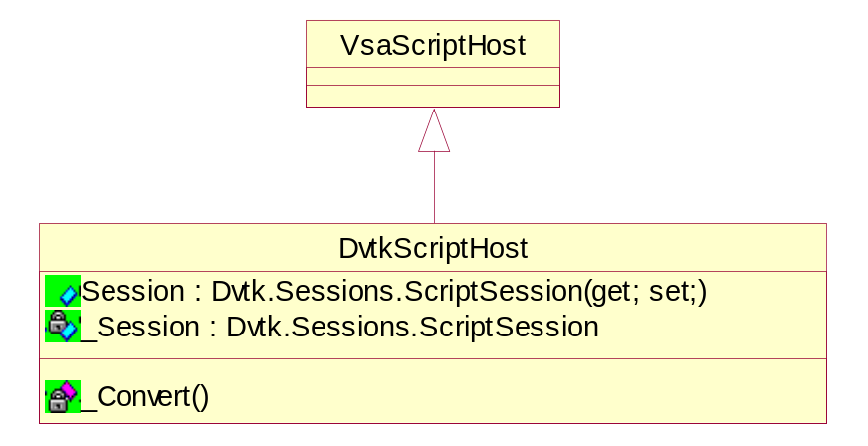
Figure 1 Class diagram of DVTKScriptHost

Properties of DvtkScriptHost Class

- Getting the base session object
public Dvtk.Sessions.ScriptSession Session(get; set;)

Methods of DvtkScriptHost class

- Representing script language enum value into string value
private static string _Convert(DvtkScriptLanguage language);

VsaScriptHost Class
This abstract class implements Microsoft.Vsa.IvsaSite interface. It is the main class of DVTKScriptSupport component.
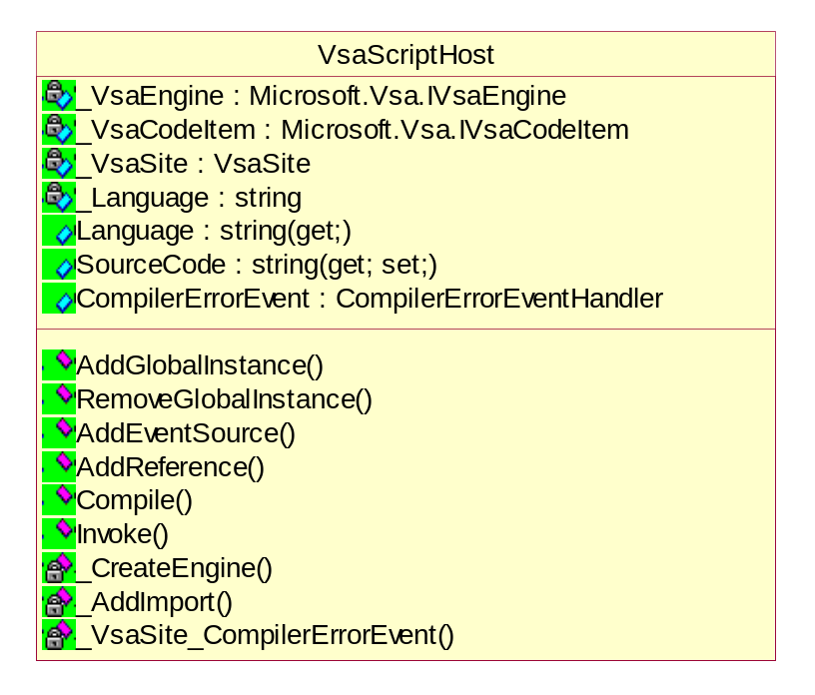
Figure 2 Class diagram of VsaScriptHost

Properties of VsaScriptHost Class

- Getting the language of the script source and the engine
public string Language(get;)

- Getting/setting the source code of executed script
public string SourceCode(get; set;)

Methods of VsaScriptHost class

- Adding/removing an object instance to the script environment
public bool AddGlobalInstance(string name, object instance);
public bool RemoveGlobalInstance(string name);

- Adding an event source to the script context
public bool AddEventSource( string eventSourceName, object instance);

- Adding a reference to the script context
public bool AddReference(string referenceItemName, string assemblyName);

- Compiling the source code within the script context
public bool Compile();

- Executing the method which is defined in the script by the moduleName and the methodName
public object Invoke(string moduleName, string methodName, object[] arguments);

- Creating an engine depending upon the script language
private void _CreateEngine();

- Adding imports to the script
internal protected void _AddImport(string nameSpace);

- Forwardingthe event from VSA site to external users
private void _VsaSite_CompilerErrorEvent(object sender, CompilerErrorEventArgs e);

Definition of Interface implemented by VsaScriptHost class
  - IScriptHost
This interface provided by the script host.
string SourceCode { get; set; }
string Language { get; }
event CompilerErrorEventHandler CompilerErrorEvent;
bool AddEventSource(
string eventSourceName,
object Instance);
bool AddReference(
string Name,
string AssemblyName);
bool AddGlobalInstance(
string name,
object instance);
bool RemoveGlobalInstance(
string name);
bool Compile();
object Invoke(
string ModuleName,
string MethodName,
object[] Arguments);

VsaSite class
This class implements Microsoft.Vsa.IvsaSite interface.
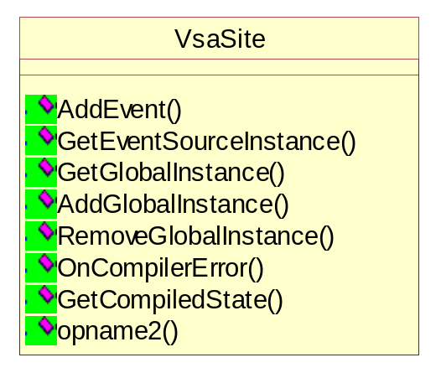
Figure 3 Class diagram of VsaSite

- Adding an event to the hash table
public void AddEvent(
string eventSourceName,
object instance);

- Getting an event source instance from the hash table
public object GetEventSourceInstance(string itemName, string eventSourceName);

- Managing a global instance
public object GetGlobalInstance(string name);
internal void AddGlobalInstance(string name, object instance);
internal void RemoveGlobalInstance(string name);

- Handler for compiler error
public bool OnCompilerError(Microsoft.Vsa.IVsaError error);

CompilerErrorEventArgs class
This class provides access to compilation errors encountered during execution of the script compilation.

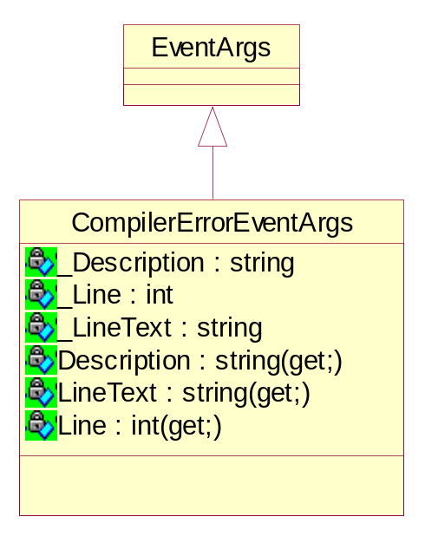
Figure 4 Class diagram of CompilerErrorEventArgs
- Getting the brief description of the error
public string Description(get;)

- Getting the line number on which an error occurs
public int Line(get;)

- Getting the text of the source code from the line that caused the error
public string LineText(get;)

Generic Visual Basic Script Classes
Generic Visual Basic Script Classes is the container of various generic classes. These classes provide wrapper over DVTK library. By using this container user can implement their test scenario specific requirements in the TestCase class. The VB scripts can be executed from the DVT GUI and DVTCmd application so there are two entry points in the DvtkScript module. In the normal run, the current session object is passed to the VB script code.

- DvtCmdMain(ByVal CmdArgs() As String)
This routine is called when executing VB script from DvtCmd application.

- Main()
This routine is called when executing VB script from DVT UI.

For debugging and analyzing the bugs/problems in the VB script in the Visual Studio, one constant DVT_INTERPRETS_SCRIPT is defined in the code. The default value of this constant is True for normal execution through the DVT GUI and DVTCmd application. Developer should modify this constant and set it to False for debugging. The ScriptContext class manages the session object and all result/definition directories for debugging purpose.

TestCaseBase class

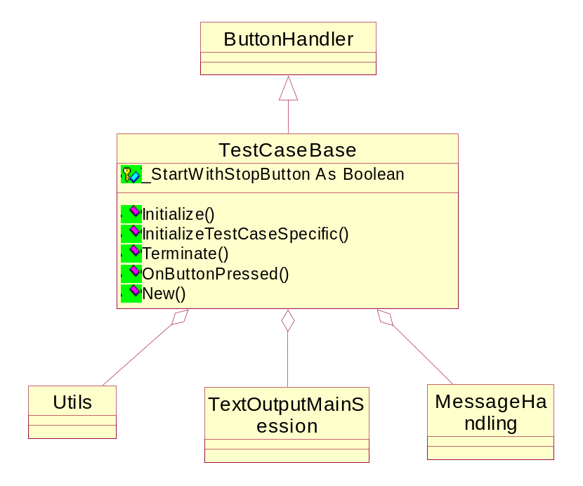
Figure 5 Class diagram of TestCaseBase
This abstract class contains the common functionality of a test case. This class handles basic functionalities of any test case should contain. It plays the role of base class of a TestCase class, which is implemented by the user. It is derived from the ButtonHandler class.
A Brief description of various member variables defined as below:
- This class aggregates the Utils, MessageHandling and TextOutputMainSession classes.

The important member functions of this class are:
- Initialize() method is called to store the session object supplied from the DVT UI or DVTCmd application. It also initializes and creates the member class variables.
This method removes the result files from the previous run and calls the InitializeTestCaseSpecific() method.
- InitializeTestCaseSpecific() method will be overridden by TestCase class and initializes the test case specific requirements.
- Terminate() method should be called for terminating any hanging network connections as well as cleaning up of holding resources like threads.
- OnButtonPressed() method should be called for User interaction and must be overridden in TestCase class. It implements default button “Stop” behavior.

TestCase class

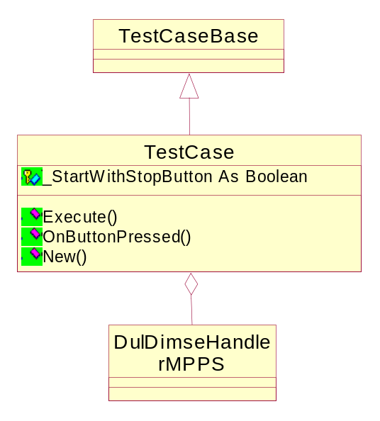
Figure 6 Class diagram of TestCase

This class emulates a test scenario and implemented by the user with the help of VB Script generic classes. It is derived from the TestCaseBase class.

The important member functions of this class are:
- Execute() method is called to execute the VB script. In the VB script procedure, the Initialize() should be first one and Terminate() method must be last one.
- OnButtonPressed() method should implement user buttons like ‘Stop’,’Continue’ etc.

Button Handler class

The class provides user interaction and also functionality to show a dialog with one or more buttons.
A descendant of this abstract class ButtonHandler implements what action needs to be taken when a button from such a dialog is pressed. A reference to this descendant is stored in the UserInteraction class.

DulDimseHandler class

The DulDimseHandler class implements a framework by which an SCP can be constructed more easily. It already contains implementation on the general handling of messages. A descendant of this class needs to implement how it should react to specific Dul and Dimse messages.
A descendant of this class MUST always override the following Function:
- Public Overridable Function HandleAssociateRequest() As Boolean
Note that this function must return a boolean indicating if the association will been accepted.
A descendant of this class may override all other Subs/Functions that are Overridable.

MessageHandling class

A collection of methods that form a wrapper (with extra intelligence) around the Dvtk and DvtkData library, that are concerned with the sending and receiving of Dul and Dimse messages.

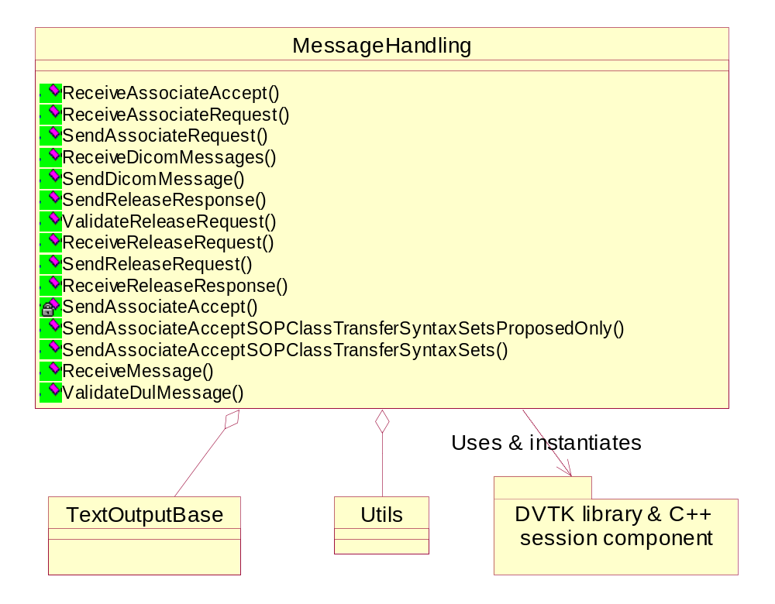
Figure 7 Class diagram of MessageHandling

ExpectedDicomMessage class

This class represents a Dicom Message (actually only the Command Set and Data Set in the Dicom message) that is expected to be receiving.
This class is used in combination with the ExpectedDicomMessageCollection class.

ExpectedDicomMessageCollection class

This class represents a collection of Dicom Messages (actually only the Command Set and Data Set in these Dicom messages) that are expected to be receiving.

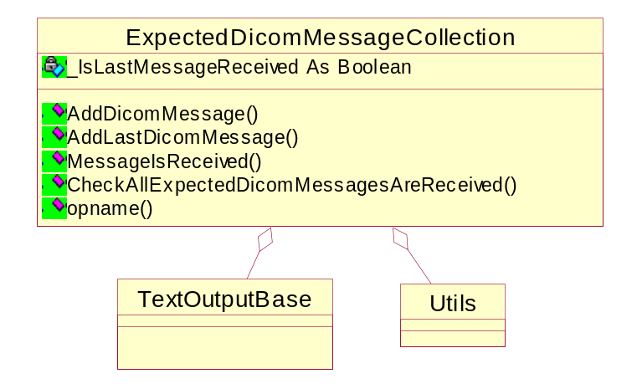
Figure 8 Class diagram of ExpectedDicomMessageCollection

SessionThread class

This is an abstract class implementing the common functionality for executing code for a specified session in a separate thread. Normally, VB script executes in single thread but complex scripts it executes in different threads.
A descendant of this abstract class only has to implement the EntryPoint method, in which to state what has to be executed in the supplied session in a separate thread.
See the class SessionThreadSingleScript for a simple example of implementing a SessionThread descendant.

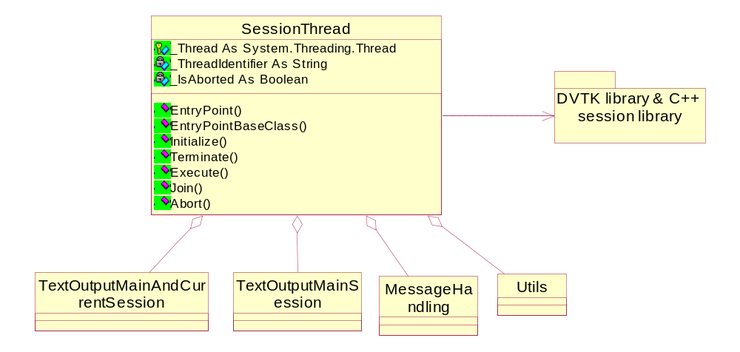
Figure 9 Class diagram of SessionThread

SessionThreadDulDimseHandler class

This class is indirectly used when the method ExecuteInThread of a DulDimseHandler descendant is called.
It takes care that the DulDimseHandler descandant is not executed in the main thread but in a separate thread.

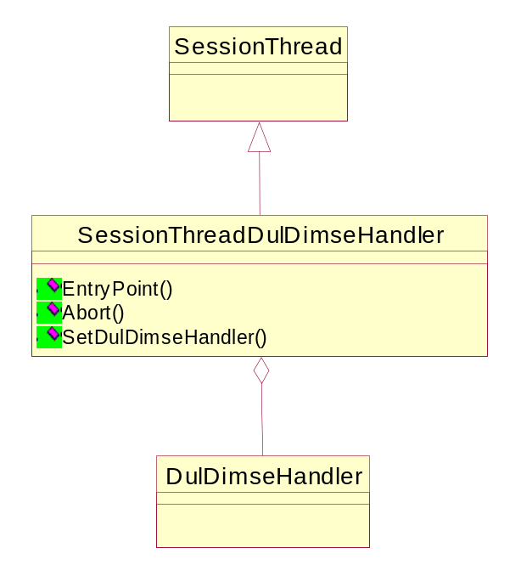
Figure 10 Class diagram of SessionThreadDulDimseHandler

SessionThreadSingleScript class

This class can be used to execute a DICOM Script or DICOM Super Script in a specified session in a separate thread.

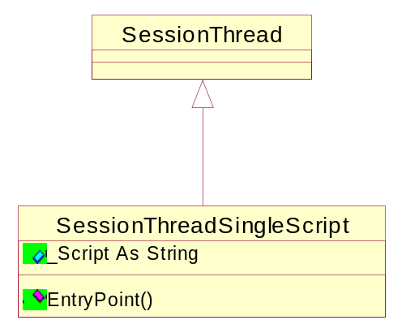
Figure 11 Class Diagram of SessionThreadSingleScript

SopClasses class

This Class contains general information about the SOP Classes.

TextOutputBase class

This abstract class is used as an abstraction layer when outputting text.
When a class uses a member of this type as the text output object, it does not need to be concerned
If the output text should be send only to the main session (using the TextOutputMainSession class) or the main session and specified current session (TextOutputMainAndCurrentSession).
So a class using a member of type TextOutputBase can be used both for executing something in the main session and for executing something in another session.

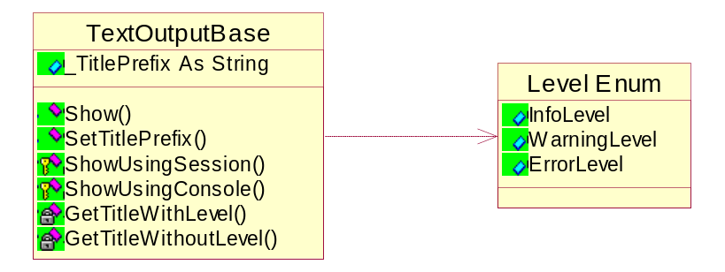
Figure 12 Class Diagram of TextOutputBase

TextOutputMainAndCurrentSession class

This TextOutputBase descendant takes care that output text is both send to the main session as the specified current session.
The main reason for having this class is to implement the following:
- Send output text to the specified current session so this information will be stored in the results file of this session.
- Send output text to the main session, so that when using the Dvt.exe this text will also be visible in the Activity logging tab. The text that the user will see in e.g. the activity logging tab will be identified with a thread identifier, to make it clear that this is not the result of execution something in the main session.

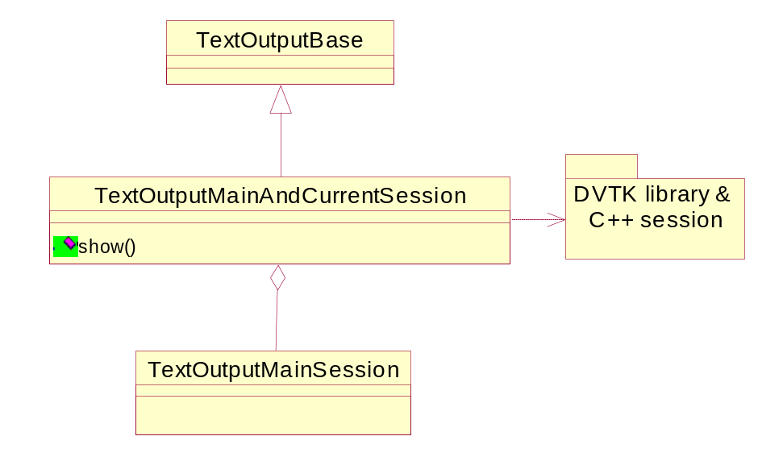
Figure 13 Class diagram of TextOutputMainAndCurrentSession

TextOutputMainSession class

This is derived from TextOutputBase class and takes care of output text that is sending to the main session.

It displays following text to the user.
- theLevel:
The loglevel used.
- formatString:
The format string (see .NET method String.Format)
- ParamArray:
The parameter array (see .NET method String.Format)

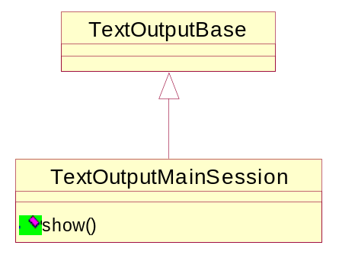
Figure 14 Class diagram of TextOutputMainSession

UserInteraction class

This class offers two main functionalities:
- Show a dialog with buttons and wait until the user presses one of those buttons.
- Show a dialog with buttons and continue execution.
A ButtonHandler descendant (which this class may point to) implements what to do when a specific button is pressed.

Utils class

This class contains the collection of methods that is not directly related to the other classes.

